**Azure Databricks – Extract, transform, and load data**

This diagram shows application/data flow:

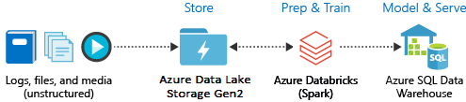

This example covers the following tasks:

* Create an Azure Databricks service.
* Create a Spark cluster in Azure Databricks.
* Create a file system in the Data Lake Storage Gen2 account.
* Upload sample data to the Azure Data Lake Storage Gen2 account.
* Create a service principal.
* Extract data from the Azure Data Lake Storage Gen2 account.
* Transform data in Azure Databricks.
* Load data into Azure Synapse.

Create an Azure Databricks service:

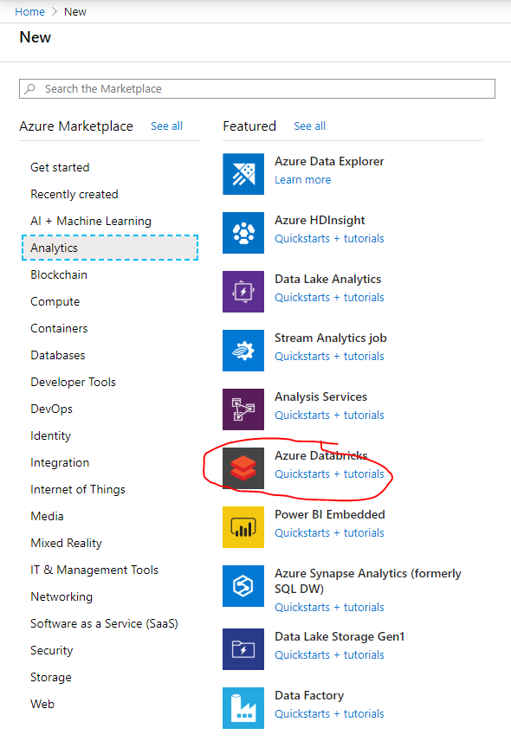

Fill in the details of the new service and click Create:

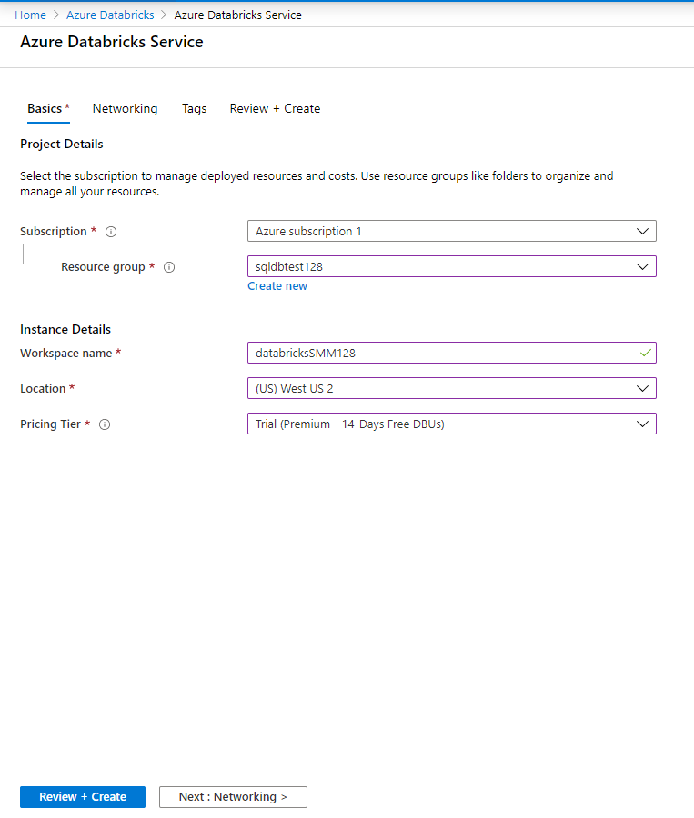

Deployment will start:

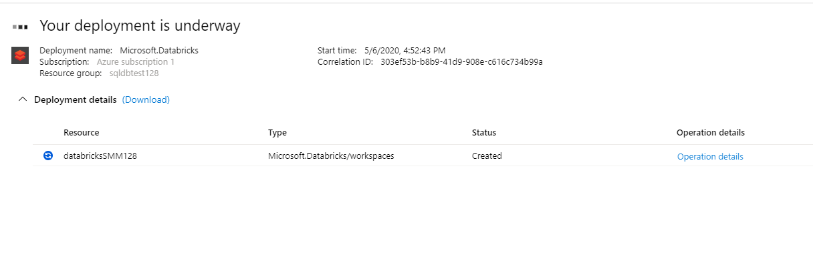

Deployment will complete as follows:

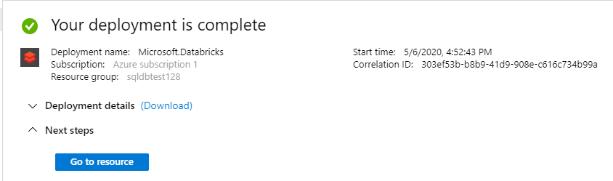

Launch the Databricks Workspace:

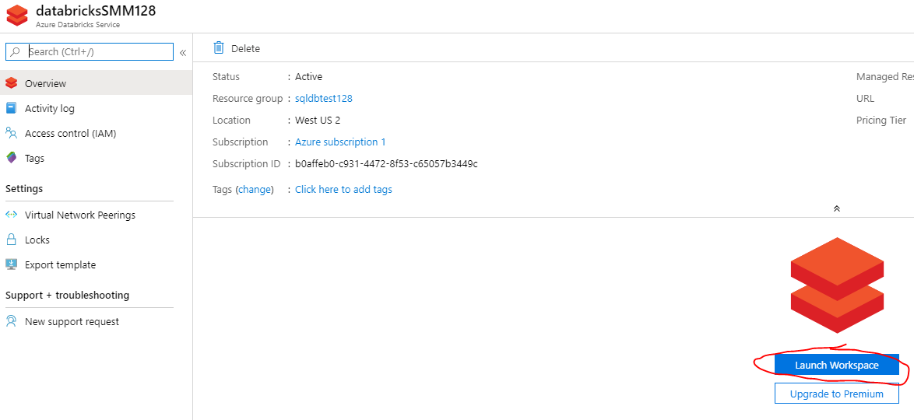

Click New Cluster:

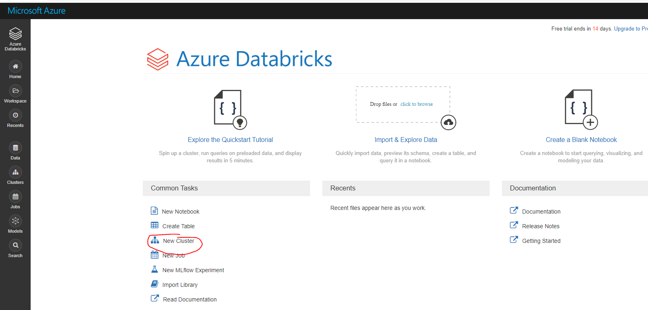

Fill in settings for the New Cluster:

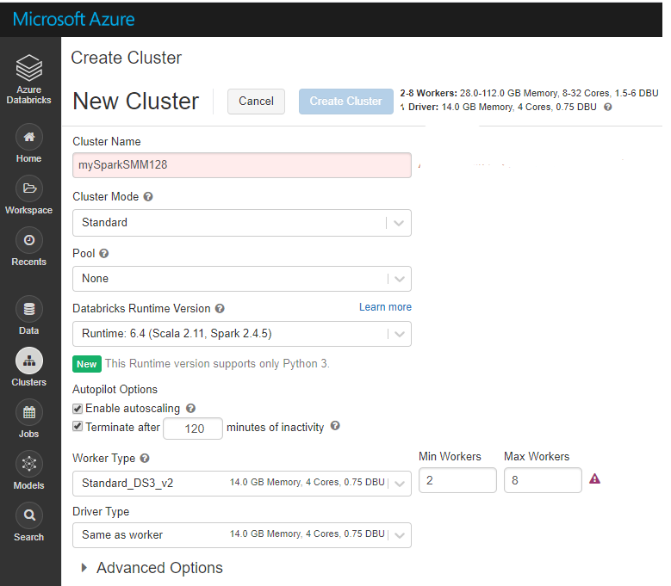

The cluster creation/deployment process will start:

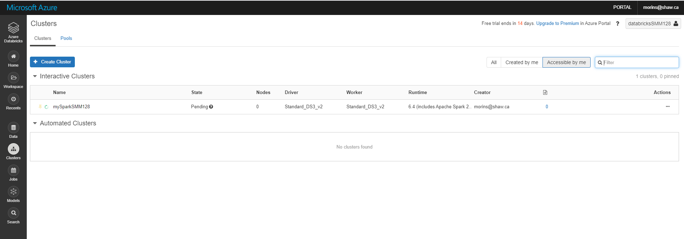

Create a New Notebook:

